**AWS SCREENSHOTS FOR CERTIFICATION – NISHA POONIA**

* AWS

1. AWS LOGIN SCREEN WITH USERNAME

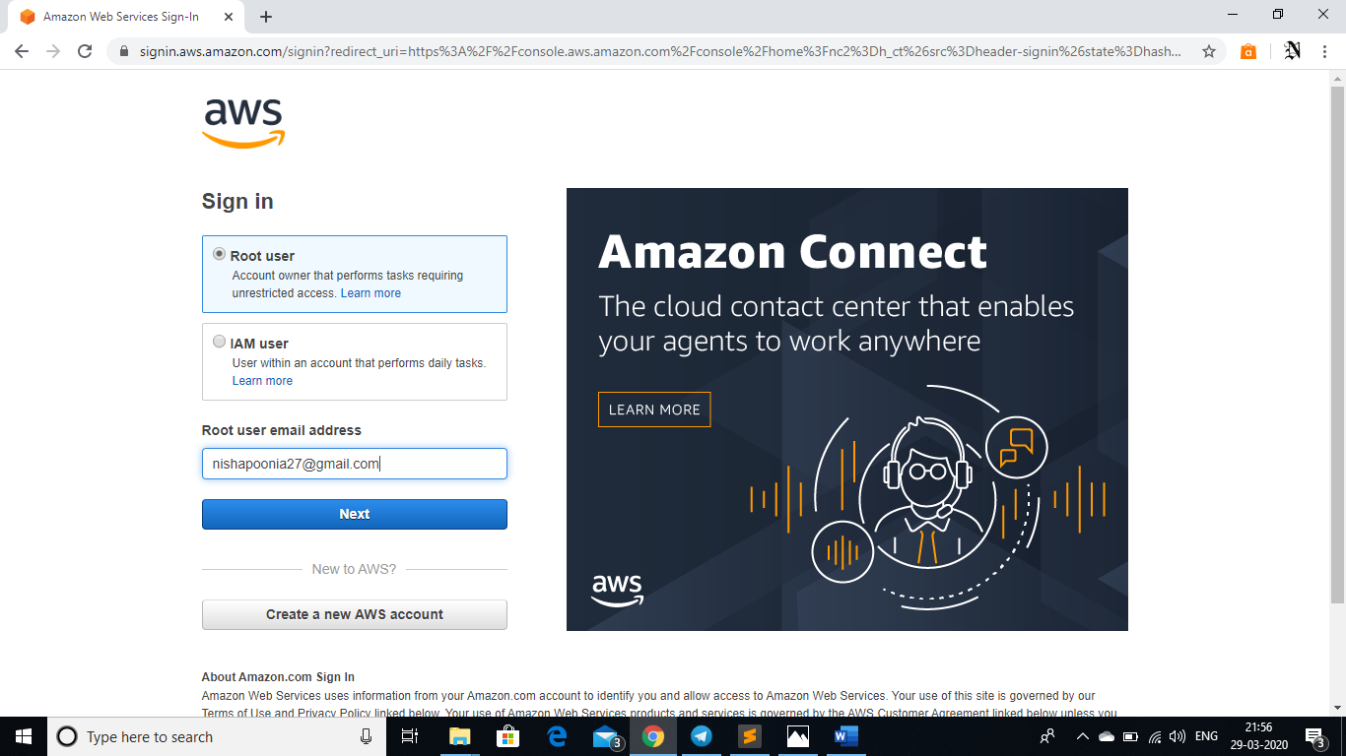

1. EC2 DASHBOARD

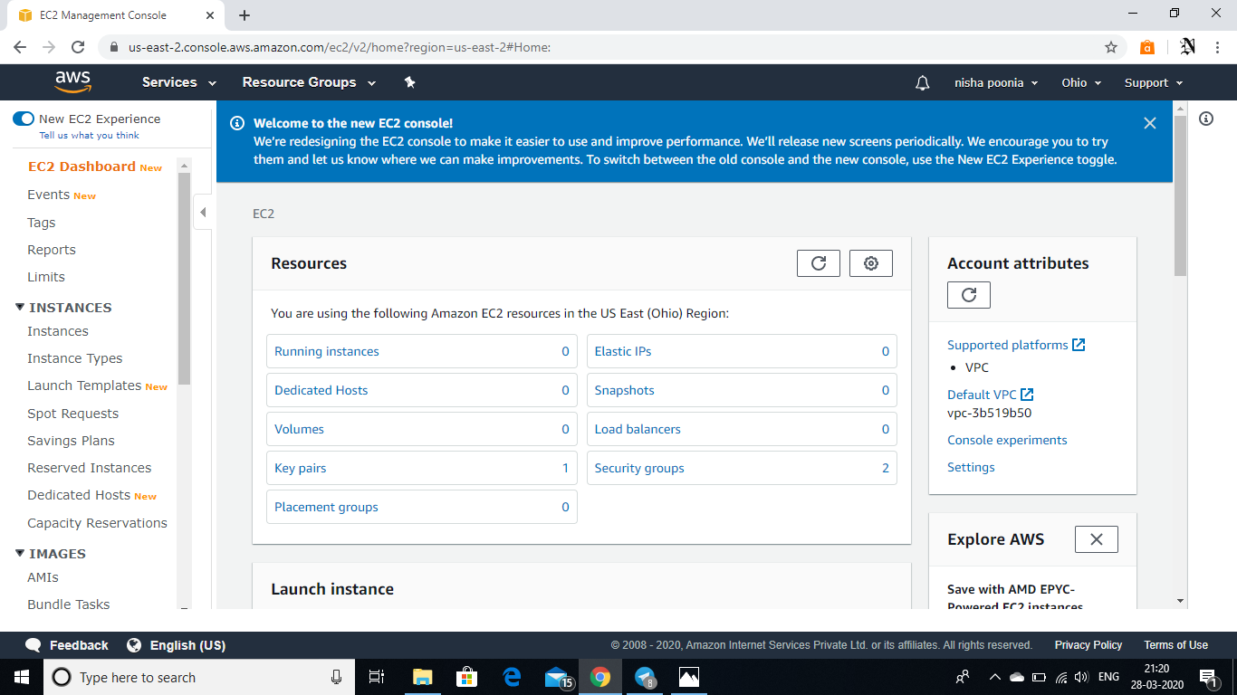

1. S3 DASHBOARD

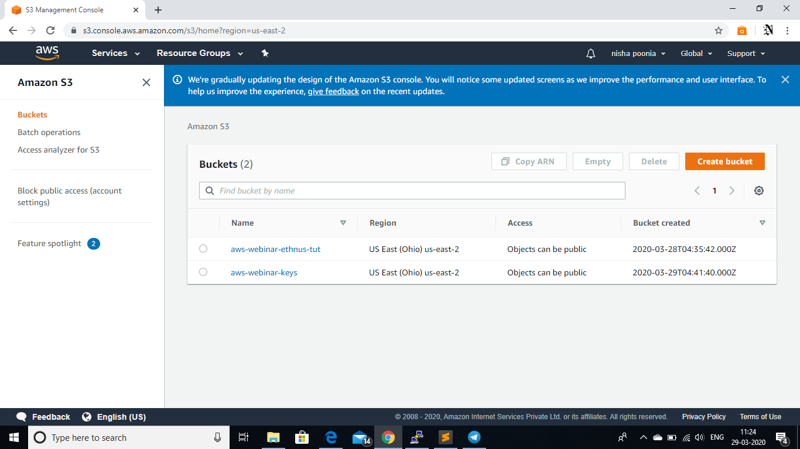

1. REKOGNITION DASHBOARD

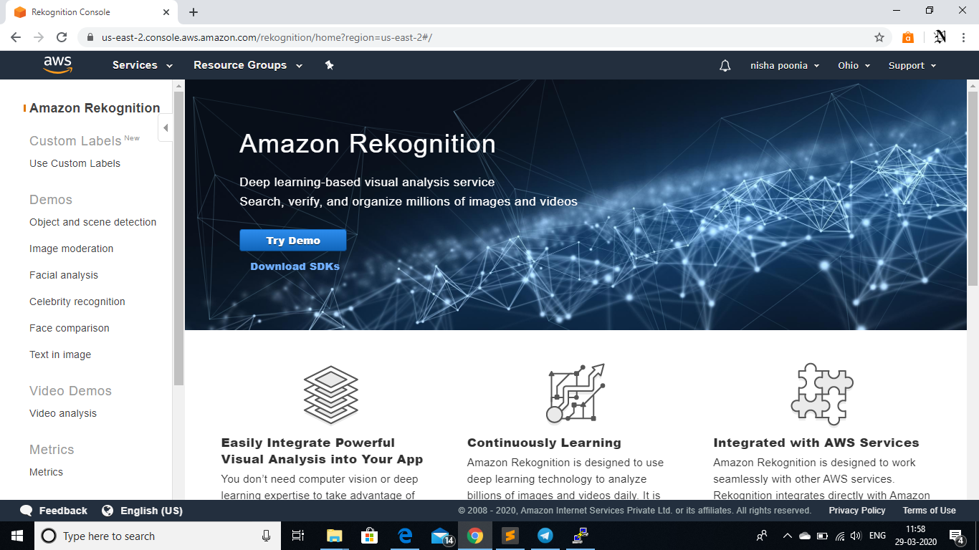

* EC2

1. CHOOSING AN AMI

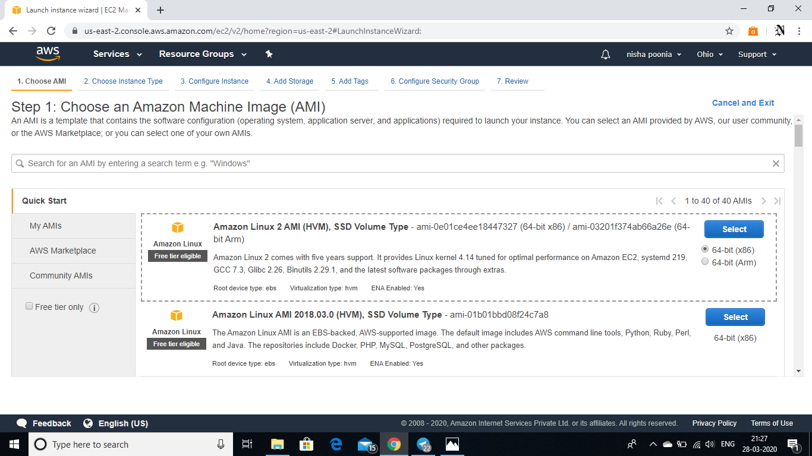

1. CHOOSING AN INSTANCE TYPE

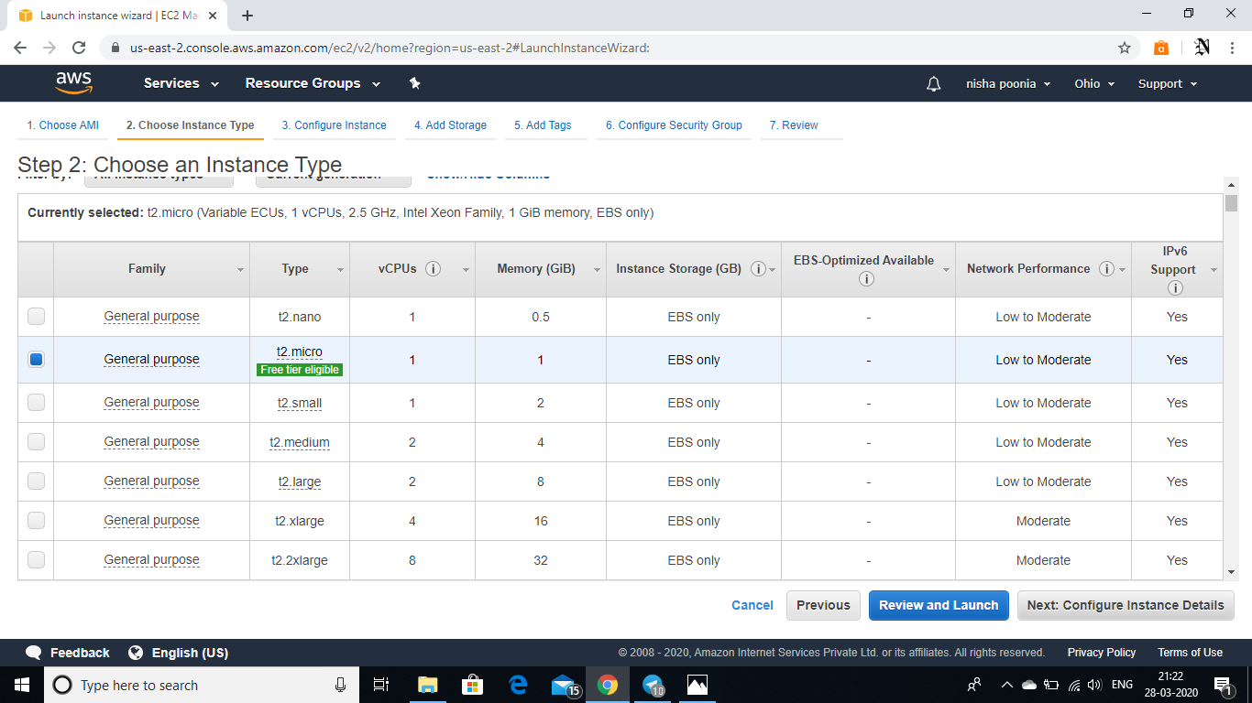

1. ADDING STORAGE

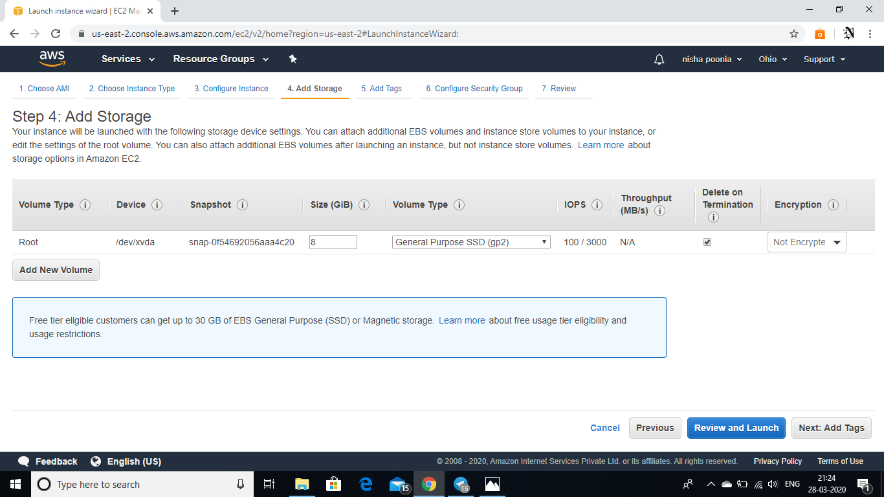

1. CONFIGURING SECURITY GROUP

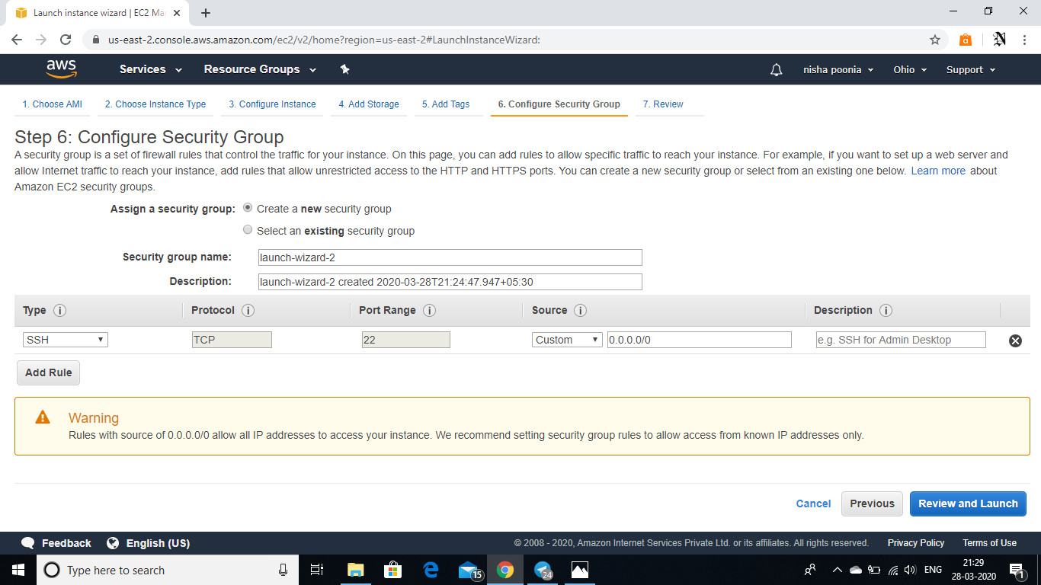

1. KEY PAIR DOWNLOAD

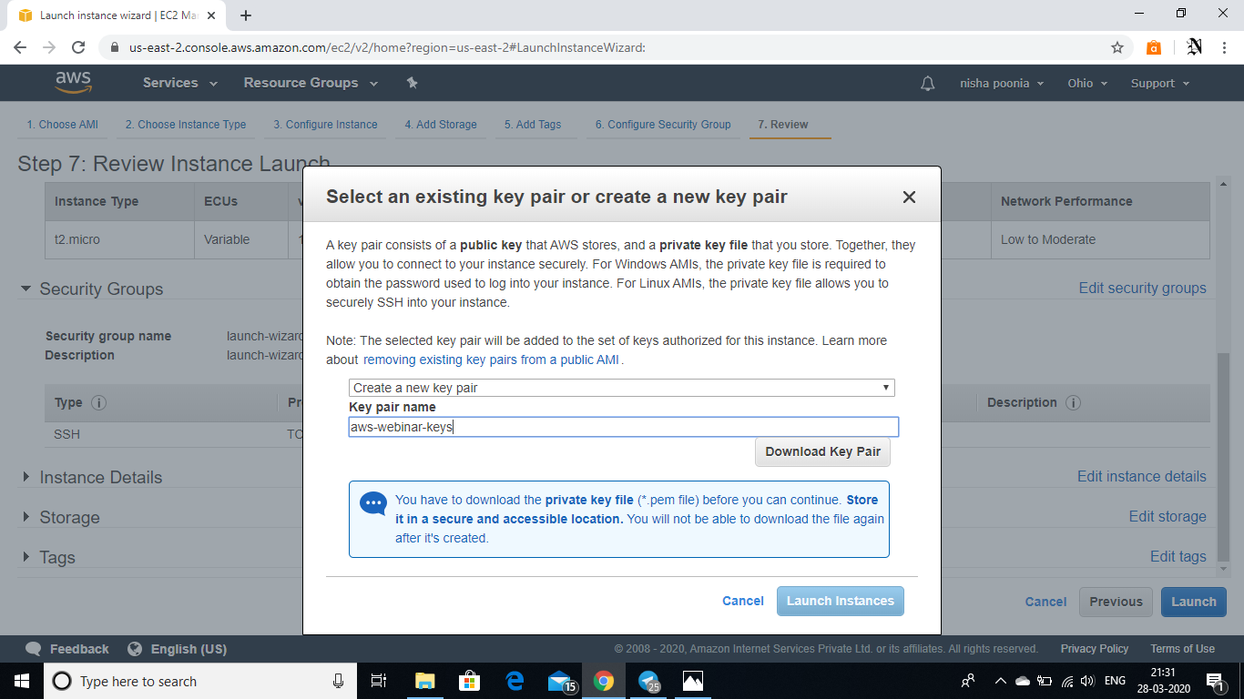

1. INSTANCE LAUNCHED

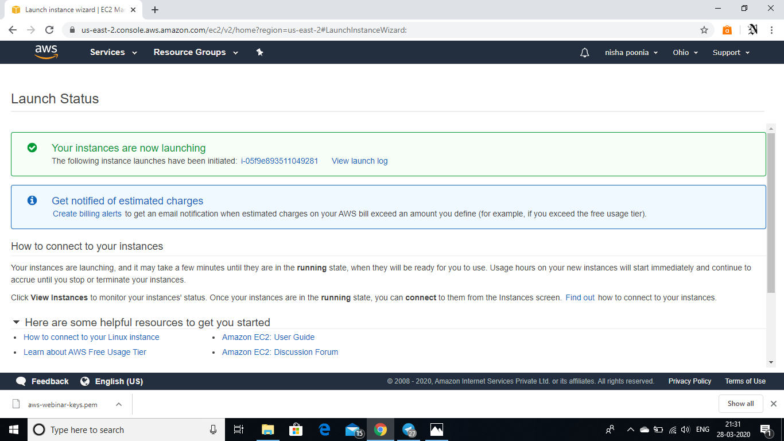

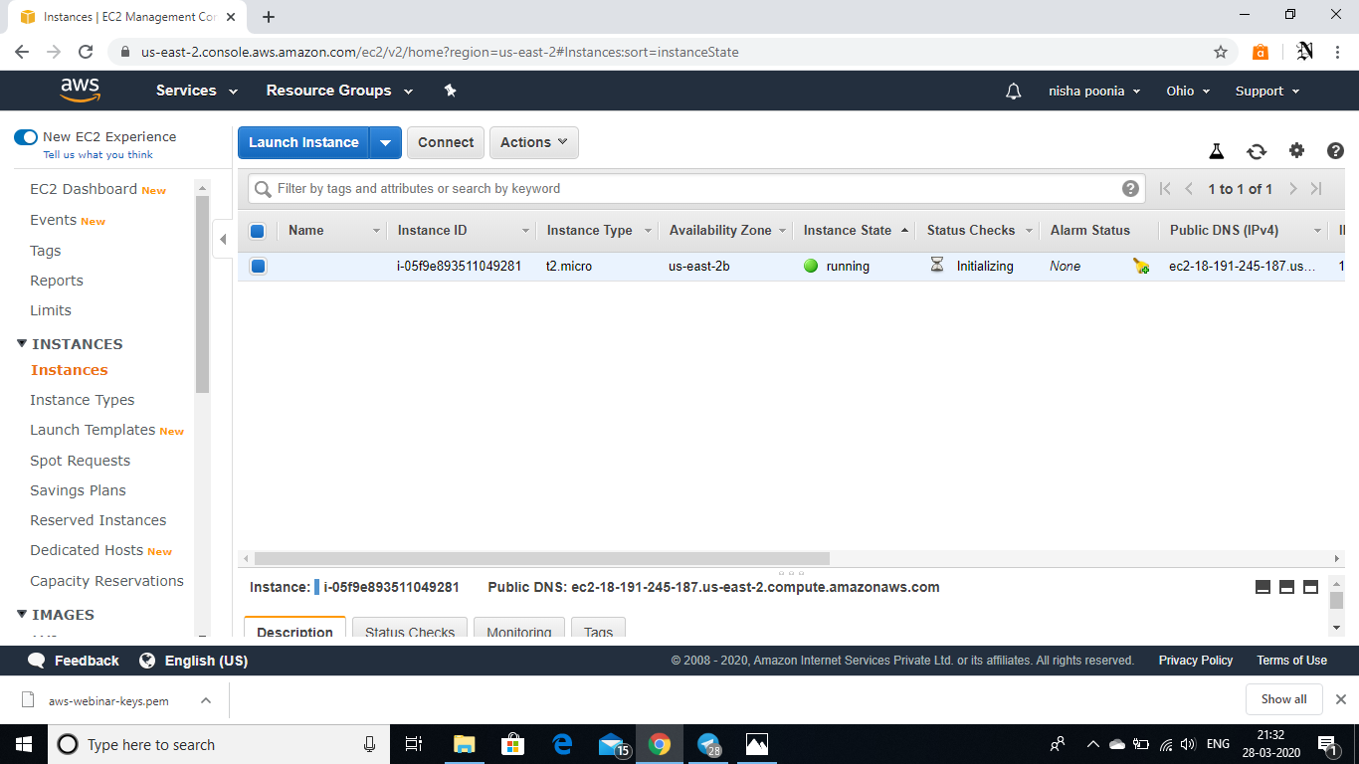

1. PuTTYgen CONVERSION FROM PEM TO PPK

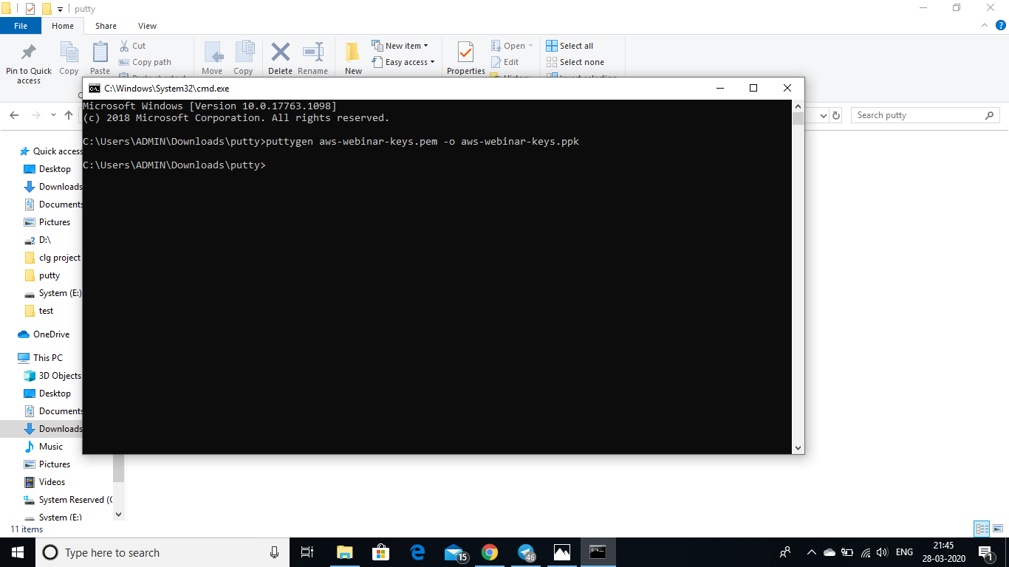

1. LOGGED IN EC2 BLANK SCREEN

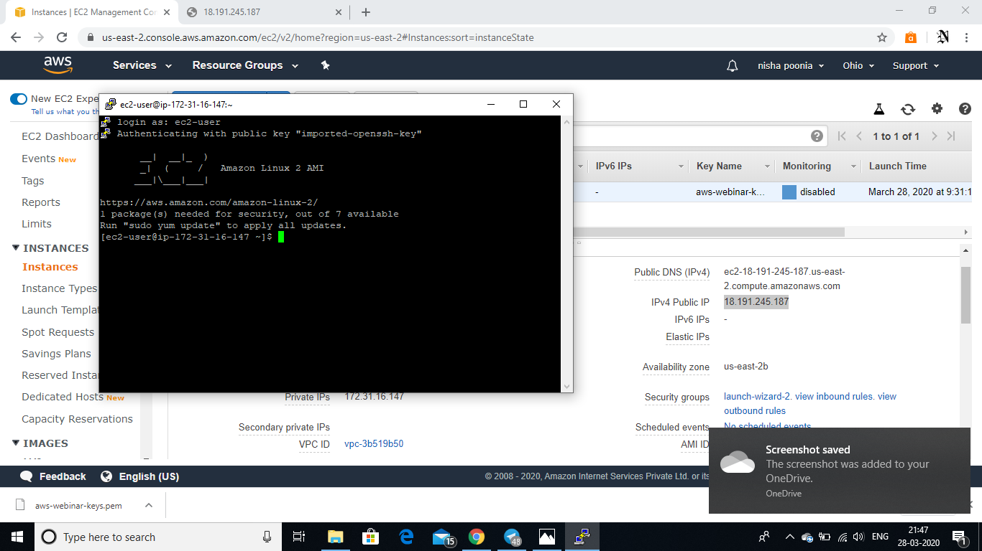

* S3

1. CREATING A BUCKET

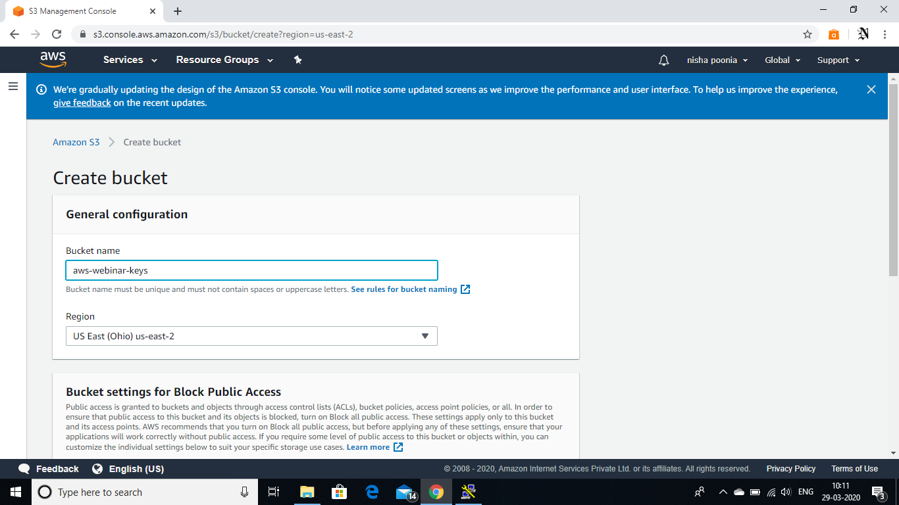

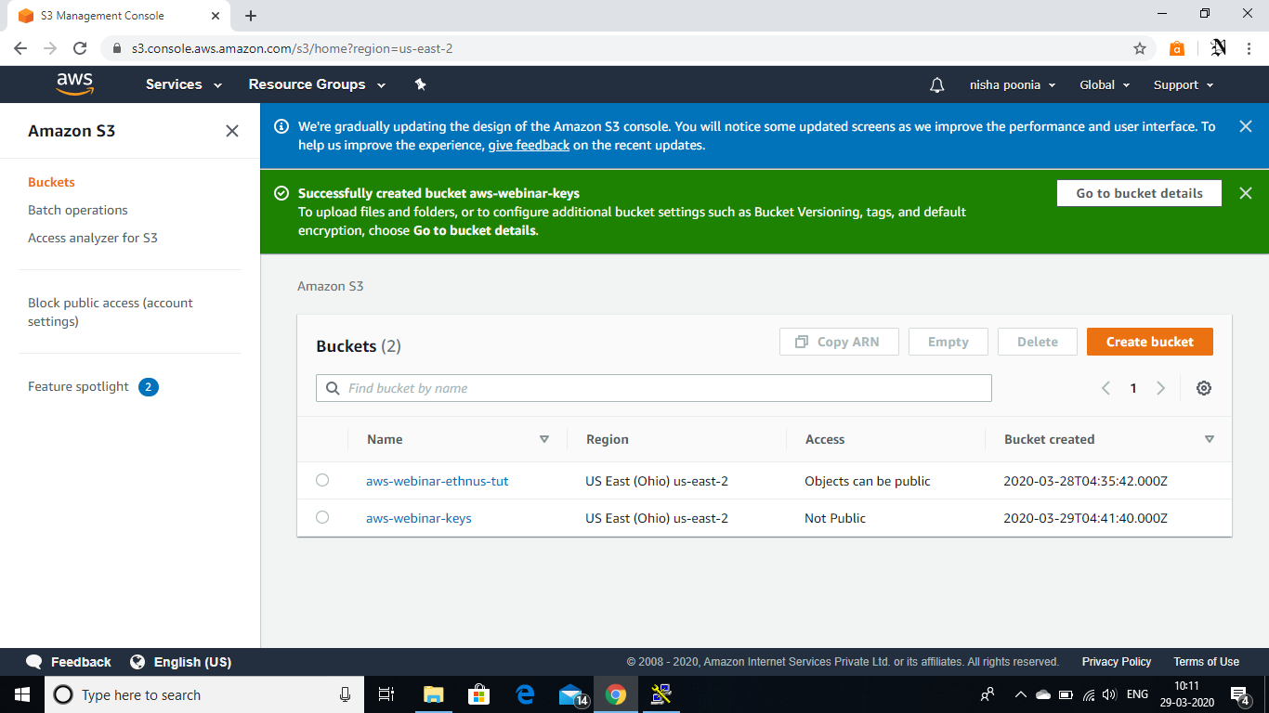

1. UPLOADING AN OBJECT

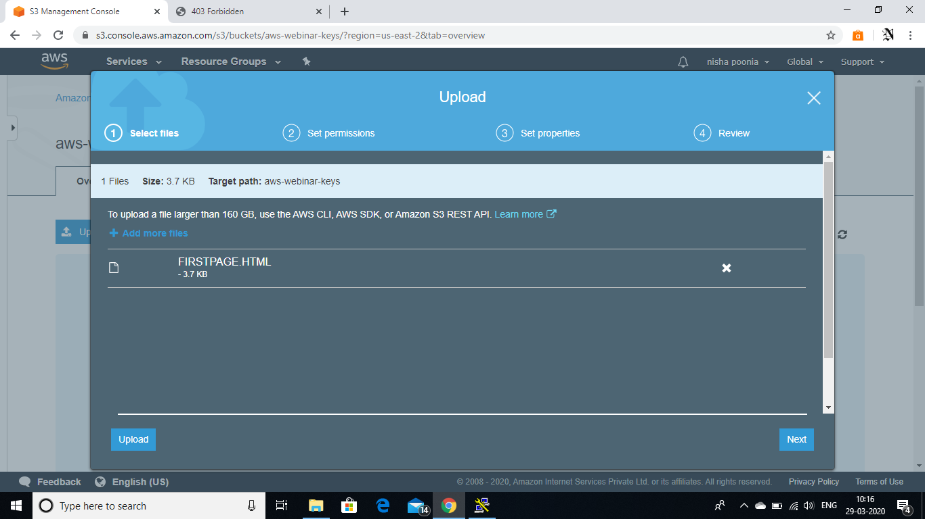

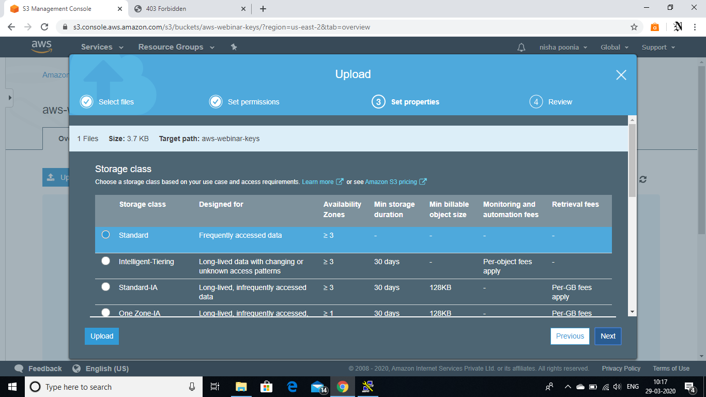

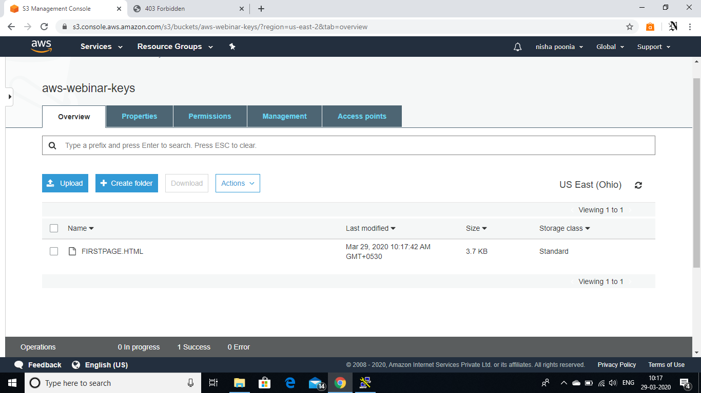

1. ENABLING STATIC WEBSITE

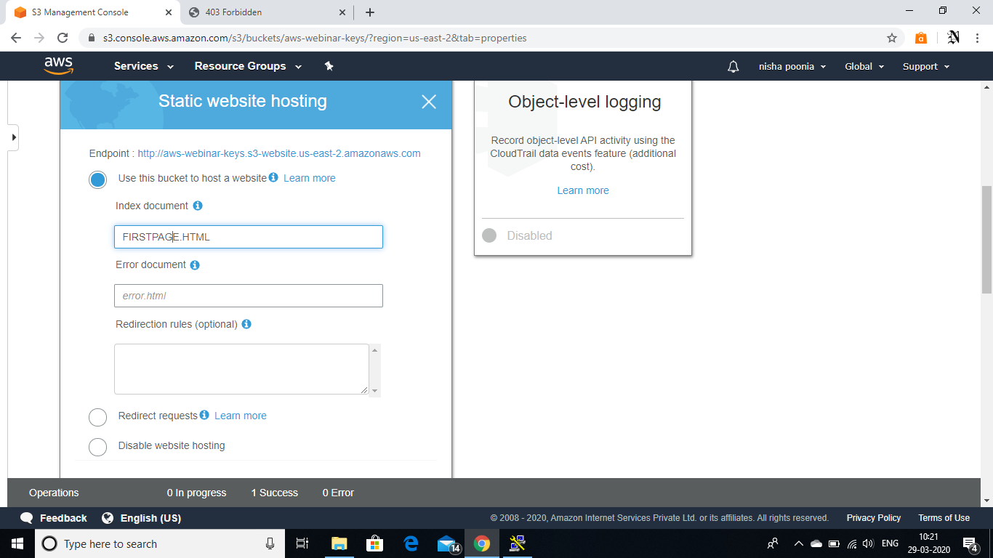

1. MAKING OBJECT PUBLIC

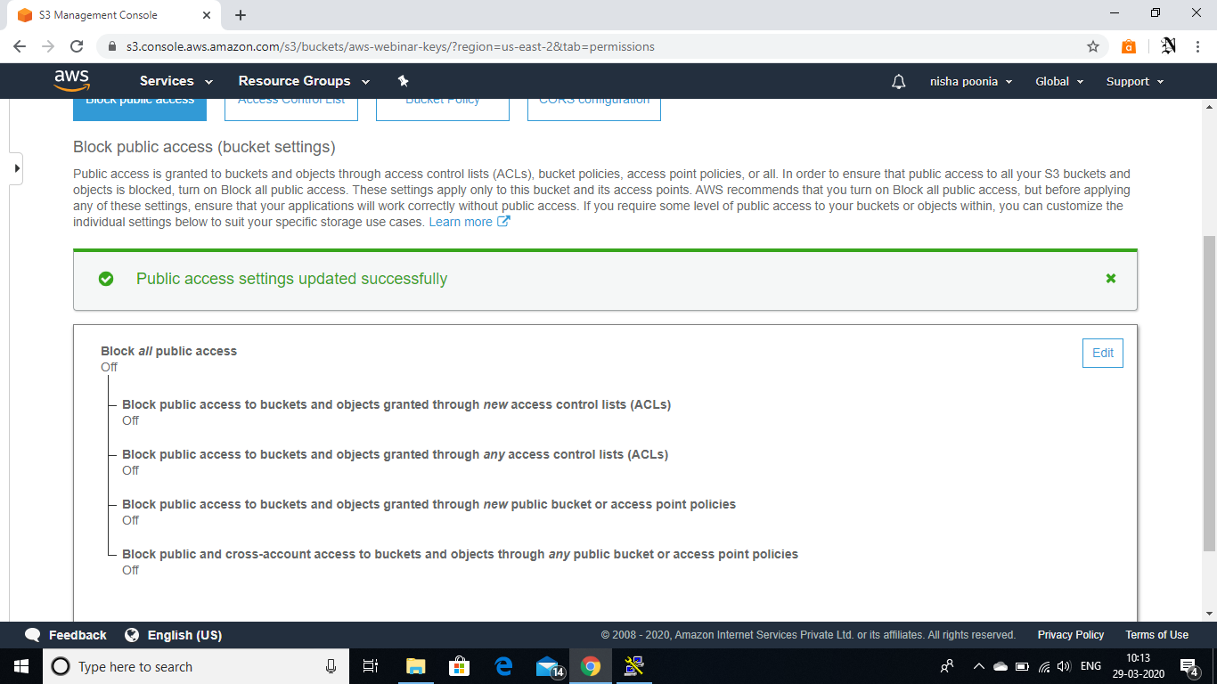

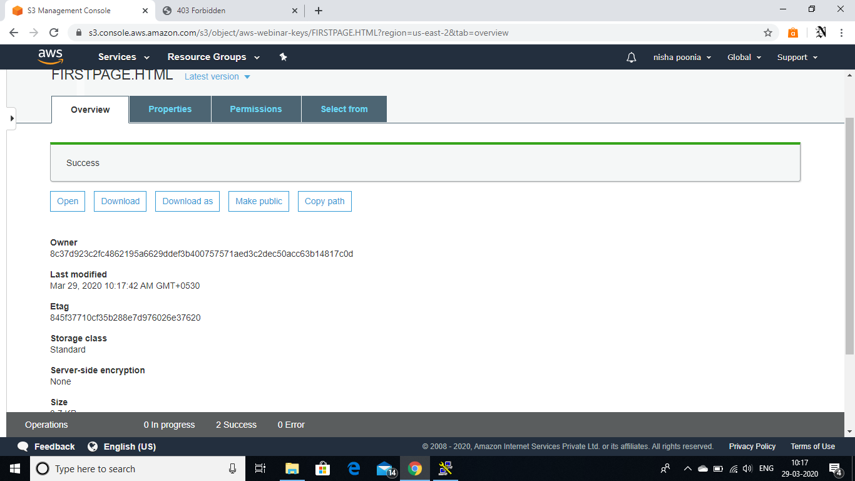

1. CHECKING S3 LINK ON THE BROWSER

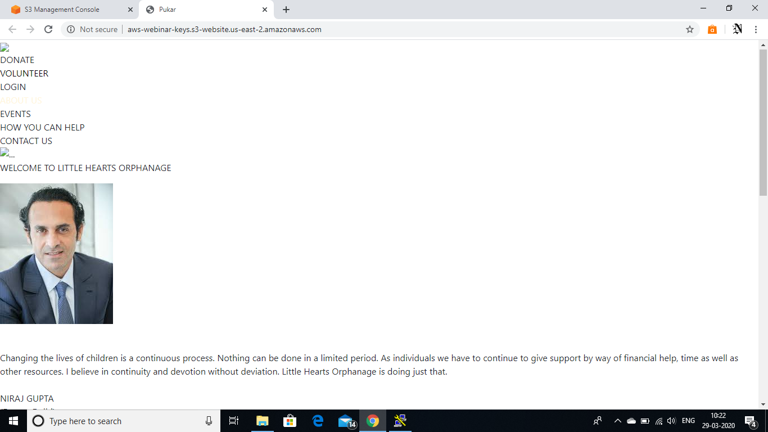

* REKOGNITION

1. FACE DETECT

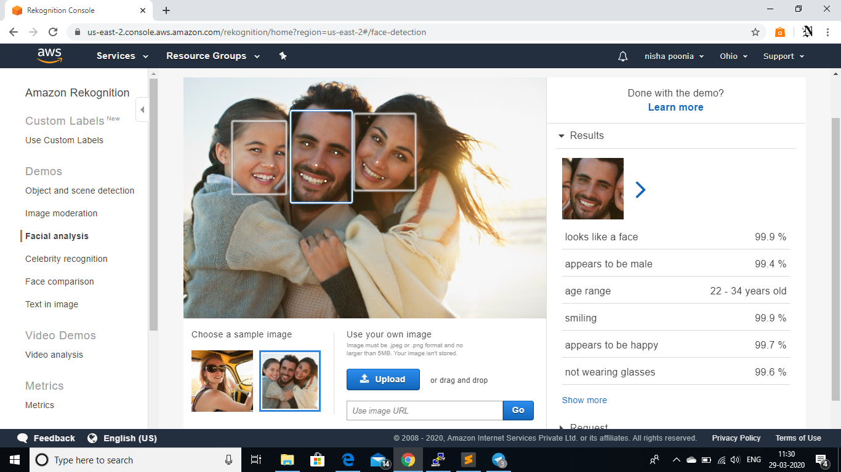

1. FACE COMPARISON

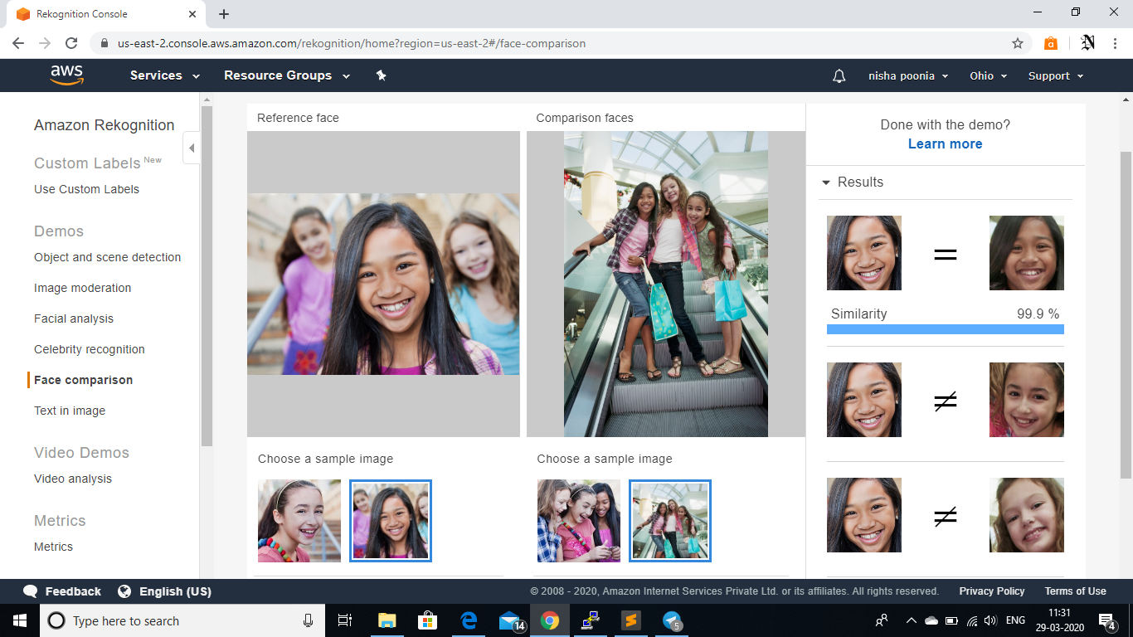

1. CELEBRITY RECOGNITION

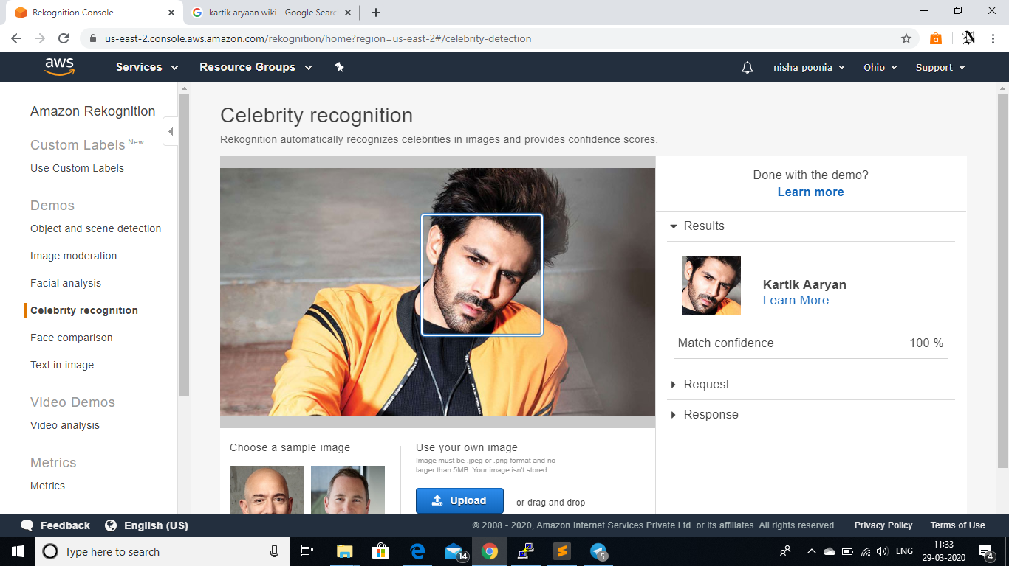

1. TEXT IN IMAGE

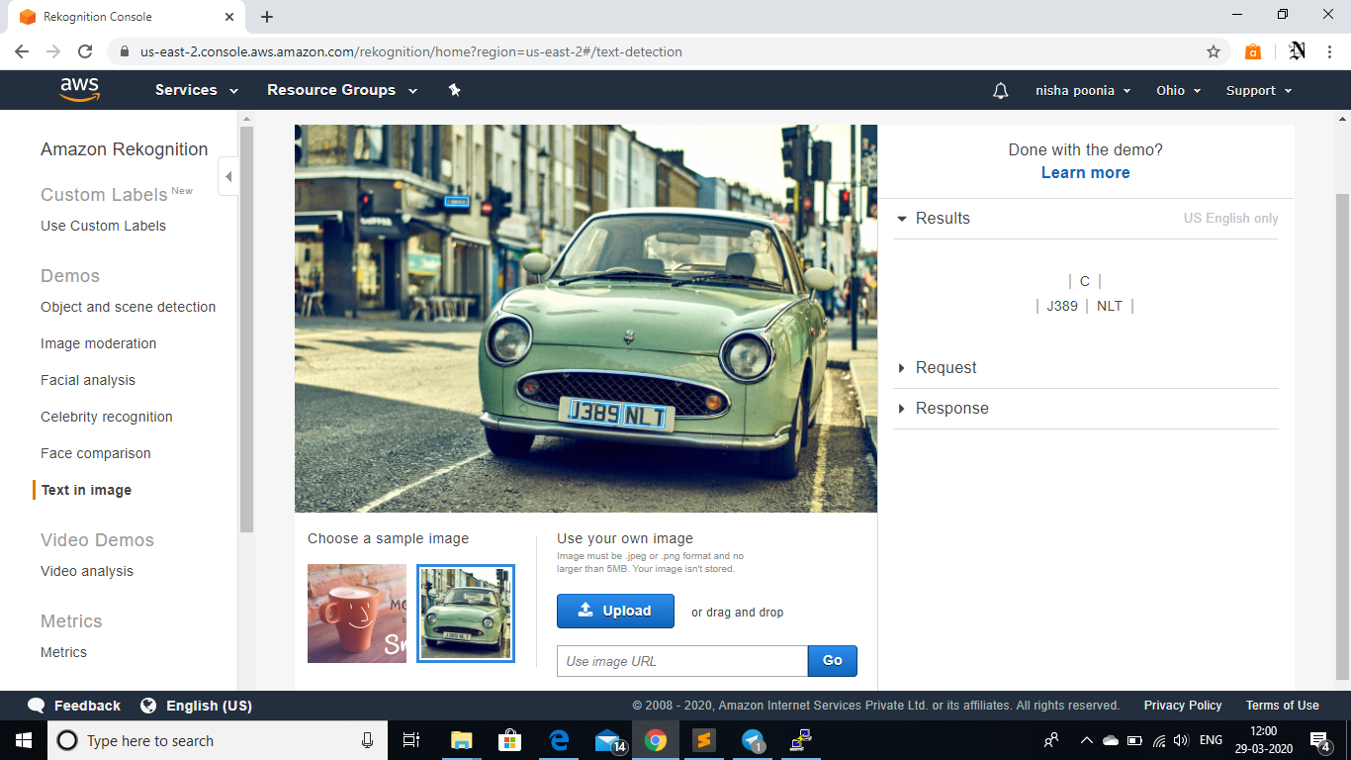

* EC2 AND S3

1. INSTALLING AWS-SDK

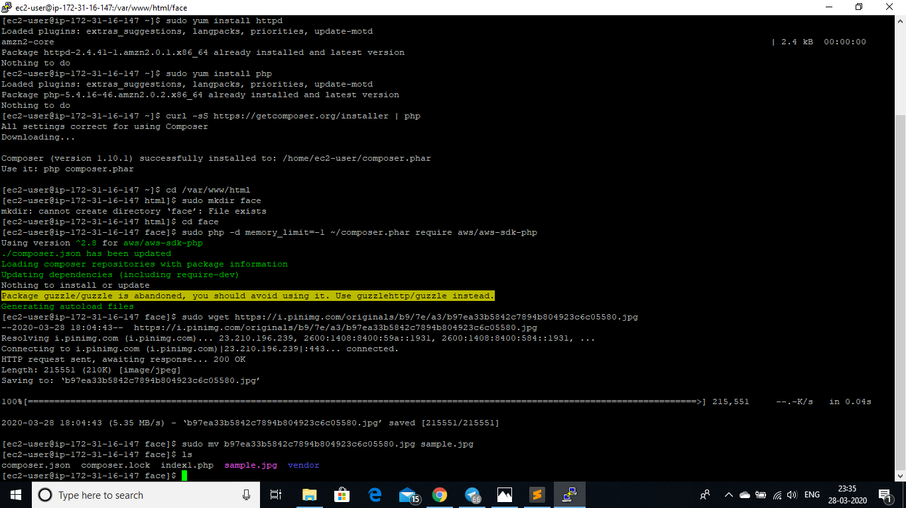

1. INSTALLING PHP



1. INDEX.PHP FILE CODE

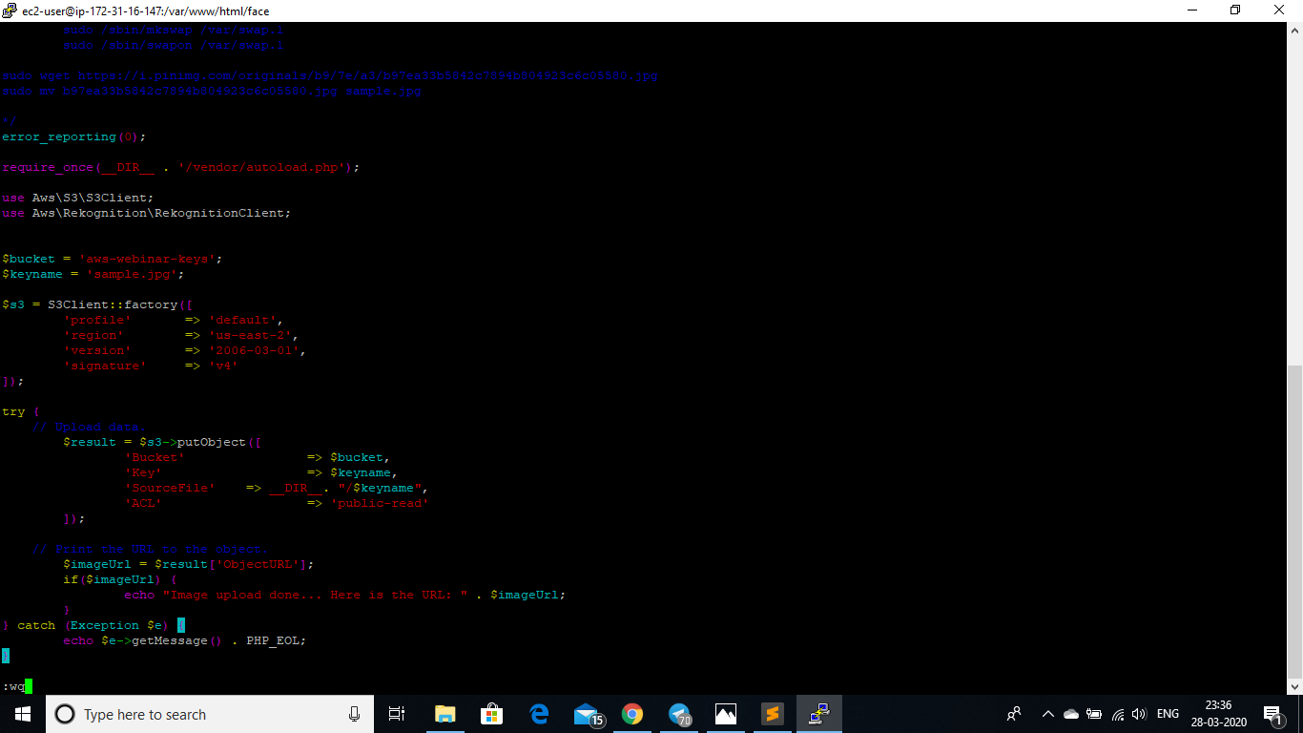

1. Success screenshot

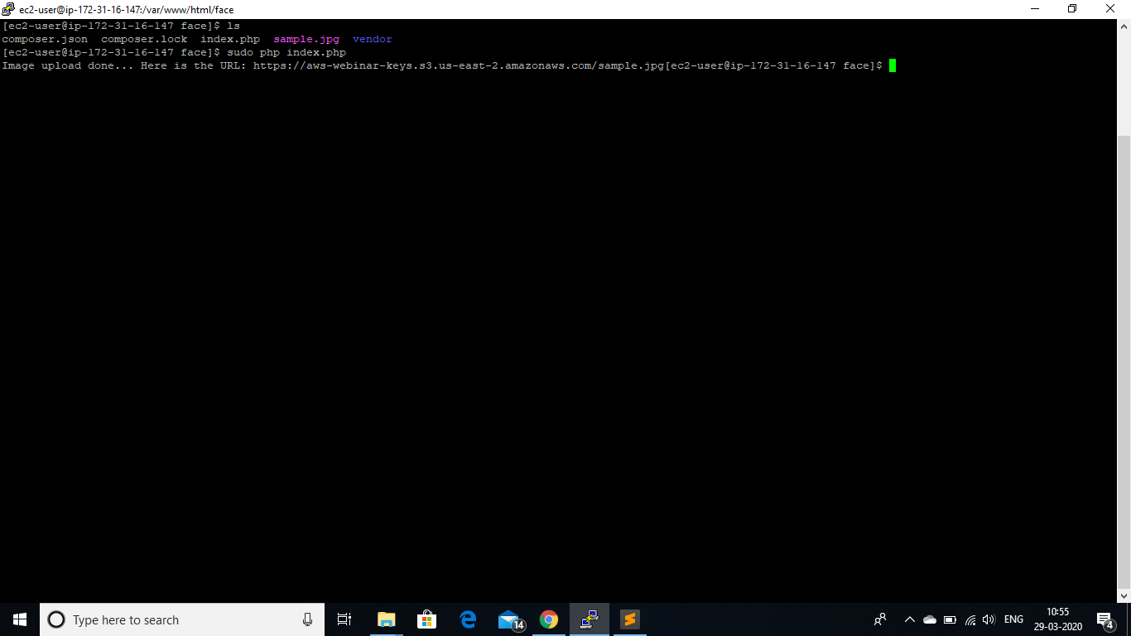

* EC2 AND REKOGNITION

1. FACE DETECT SUCCESS SCREENSHOT

